Deployment Runbook – Hospital Prediction System
Contents
2. AWS EC2 Deployment (Detailed Steps) 2
2.1 AWS Architecture 2
2.2 Launch Instance 2
2.3 Key Pair Creation 3
2.4 Security Group 3
2.5 Connect to Instance 3
2.6 Upload via CloudShell (IMPORTANT) 3
2.7 Setup Environment 3
2.8 Install Requirements 3
2.9 Run API 3
2.10 Run UI 4
2.11 Access 4
3. Local Deployment (Step by Step) 5
4. Monitoring & Logs 6
5. Drift Detection 6
6. Conclusion 6

2. AWS EC2 Deployment (Detailed Steps)
This guide explains how to deploy the Hospital Risk & Claim Intelligence FastAPI service to Amazon Web Services (AWS) using an EC2 instance. The deployment allows hospital dashboards and internal systems to access machine learning predictions in real time.
Important Notes:
- Keep .pem file safe.
- Use public IP to access API.
- Ensure port 8000 & 7860 are open.
- Stop instance when not in use to save cost.

2.1 AWS Architecture
Client Applications (Dashboards / UI)
│
▼
FastAPI Server (AWS EC2)
│
▼
Machine Learning Models (risk_model.pkl, claim_model.pkl)
│
▼
Prediction Logs (prediction_logs.csv)

2.2 Launch Instance
Go to AWS Console → EC2 → Launch Instance
Select Ubuntu 22.04
Instance Type: t2.micro
Storage: Minimum 20GB

2.3 Key Pair Creation
Create new key pair → RSA → Download .pem file
IMPORTANT: Save securely

2.4 Security Group
Allow:
Port 22 → SSH
Port 8000 → API
Port 7860 → UI

2.5 Connect to Instance
chmod 400 your-key.pem
ssh -i your-key.pem ubuntu@<PUBLIC_IP>

2.6 Upload via CloudShell (IMPORTANT)
Open AWS CloudShell
Upload:
- your-key.pem
- hospital_prediction_system.zip
Run:
chmod 400 your-key.pem
scp -i your-key.pem hospital_prediction_system.zip ubuntu@<PUBLIC_IP>:/home/ubuntu/

2.7 Setup Environment
sudo apt update
sudo apt install python3-pip python3-venv unzip -y
unzip hospital_prediction_system.zip
cd hospital_prediction_system

2.8 Install Requirements
python3 -m venv venv
source venv/bin/activate
pip install -r requirements.txt

2.9 Run API
./run.sh &
OR
uvicorn app.main:app --host 0.0.0.0 --port 8000

2.10 Run UI
Open new terminal:
cd hospital_prediction_system
source venv/bin/activate
python app/ui.py

2.11 Access
Swagger:
http://<PUBLIC_IP>:8000/docs
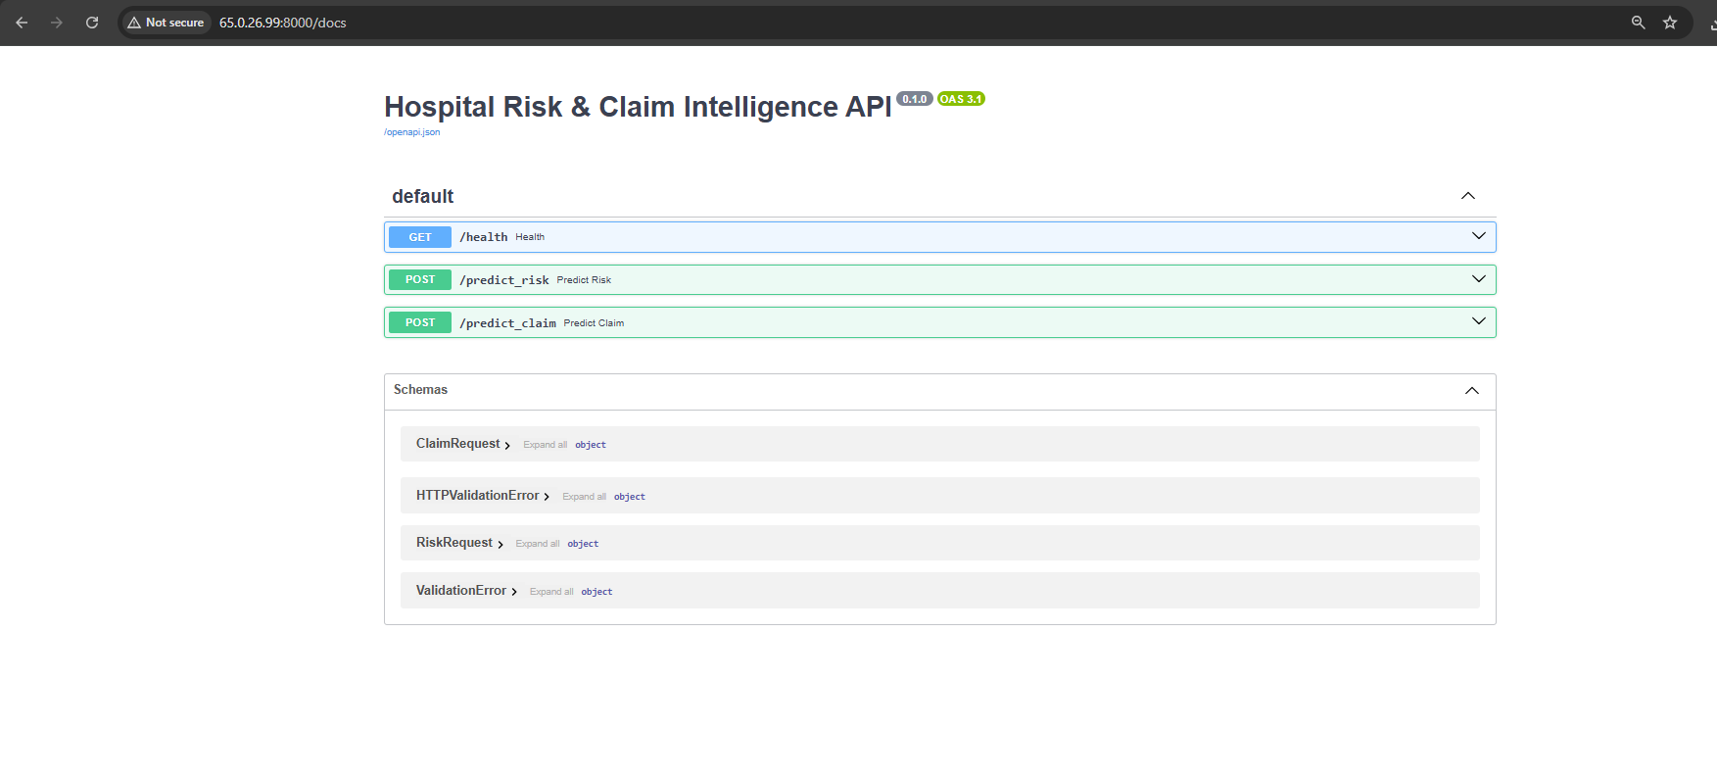
UI:
http://<PUBLIC_IP>:7860
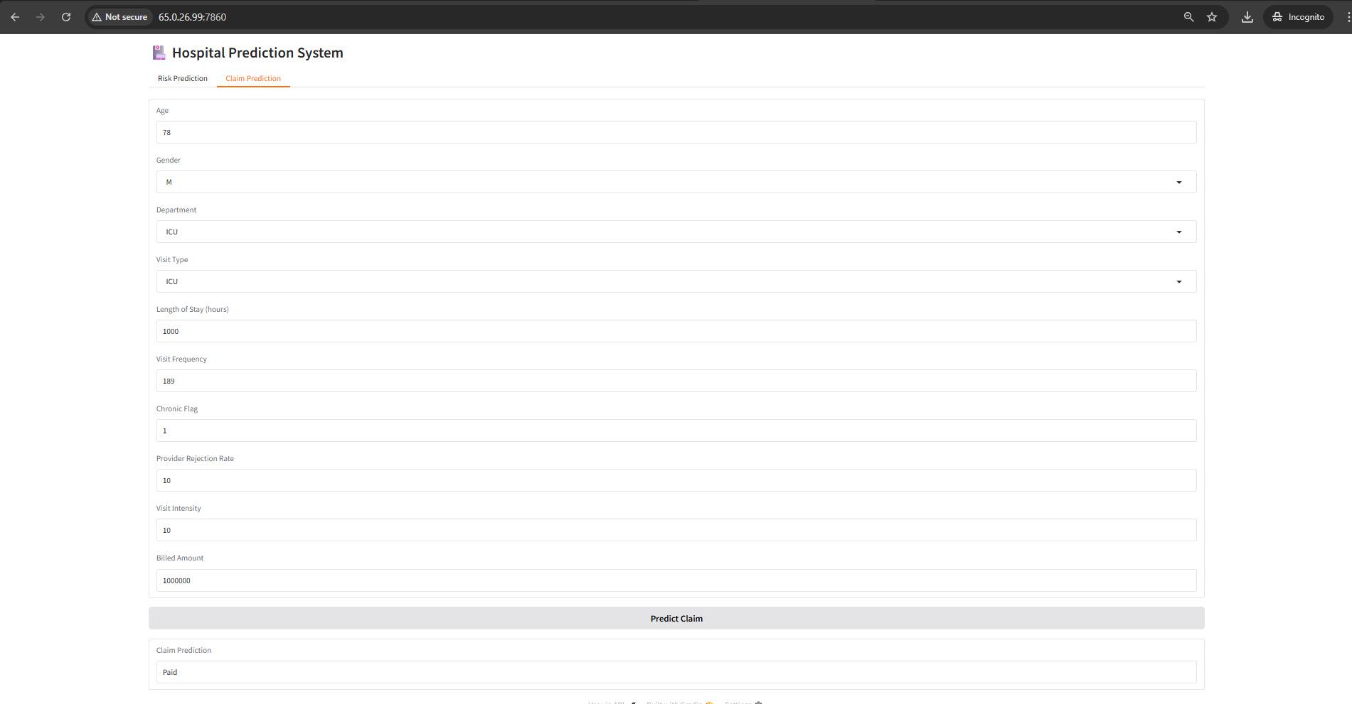
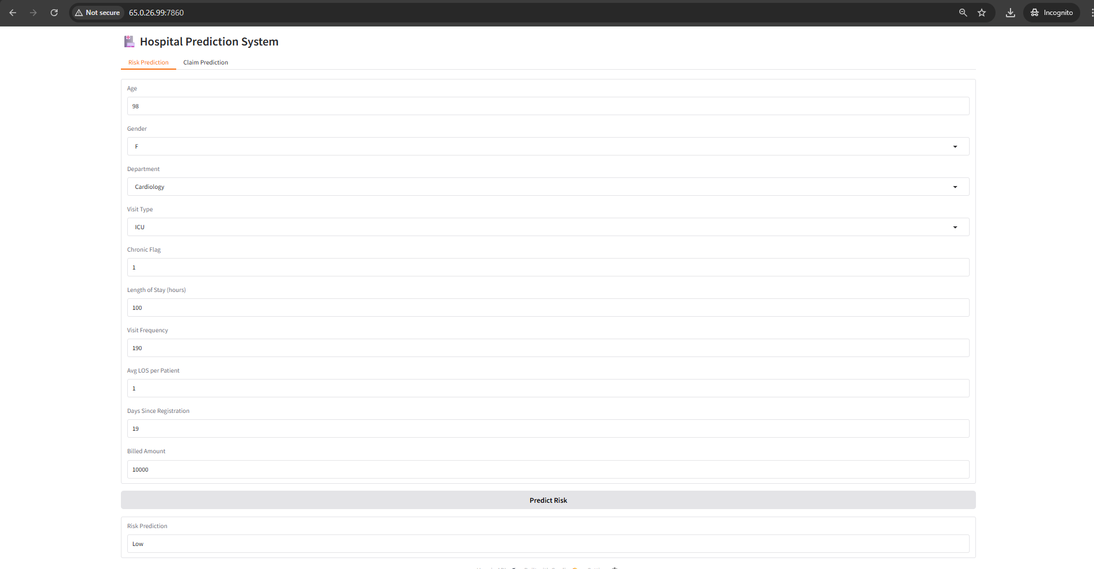

3. Local Deployment (Step by Step)
Step 1: Install Python (3.10+)
Step 2: Open terminal in project folder
Step 3: Install dependencies:
sudo apt update
sudo apt install python3-pip python3-venv unzip -y
unzip hospital_prediction_system.zip
cd hospital_prediction_system
python3 -m venv venv
source venv/bin/activate
pip install -r requirements.txt
Step 4: Run API:
uvicorn main:app --reload
Step 5: Open browser:
http://127.0.0.1:8000/docs
Step 6: Run UI:
python ui.py

4. Monitoring & Logs
risk_predictions_log.csv
claim_predictions_log.csv
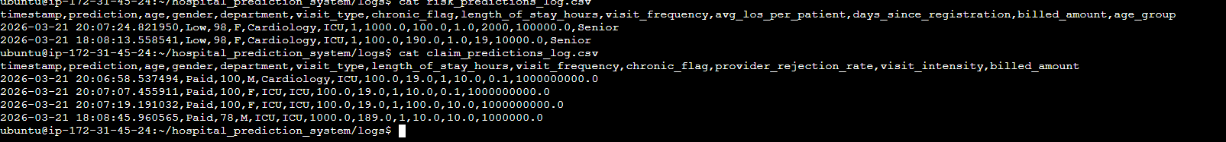

5. Drift Detection
Run:
python monitoring/advanced_drift_detection.py
Output:
drift_report.txt
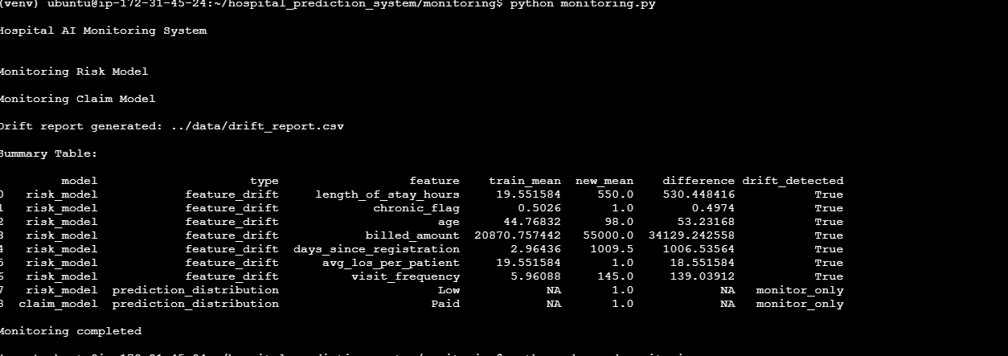
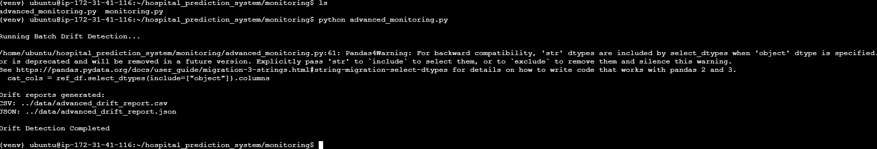

6. Conclusion
The FastAPI deployment on AWS EC2 enables real-time access to machine learning predictions for hospital operational and financial workflows. The architecture supports integration with dashboards and internal systems while maintaining logging for governance and monitoring.

